Chapter 3. Physical Characteristics
Several maps herein have been produced using publicly available spatial data from county, state and federal sources. The maps and information included serve to provide in-depth information regarding the lands within the Township to guide stakeholders. By knowing the limitations and particular features of the area, both natural and man-made, policy makers are better equipped to consider the appropriateness of both current and future land uses.

Map 3.1. Topography
Township geography generally subscribes to a downward slope from the southwest corner to the northwest, though varies with an abundance of geologic oddities. The Jaarda Drain and Rabbit River depression in Sections 28 and 36, for instance, present sizeable incongruities in the Township’s southern half. Likewise, seemingly dry tributaries to the south branch of the Macatawa River in the Township’s northeast corner sit even lower than the already low area, carving winding gullies across Sections 11 and 12.
Topography is illustrated in Map 3.1 on the following page.
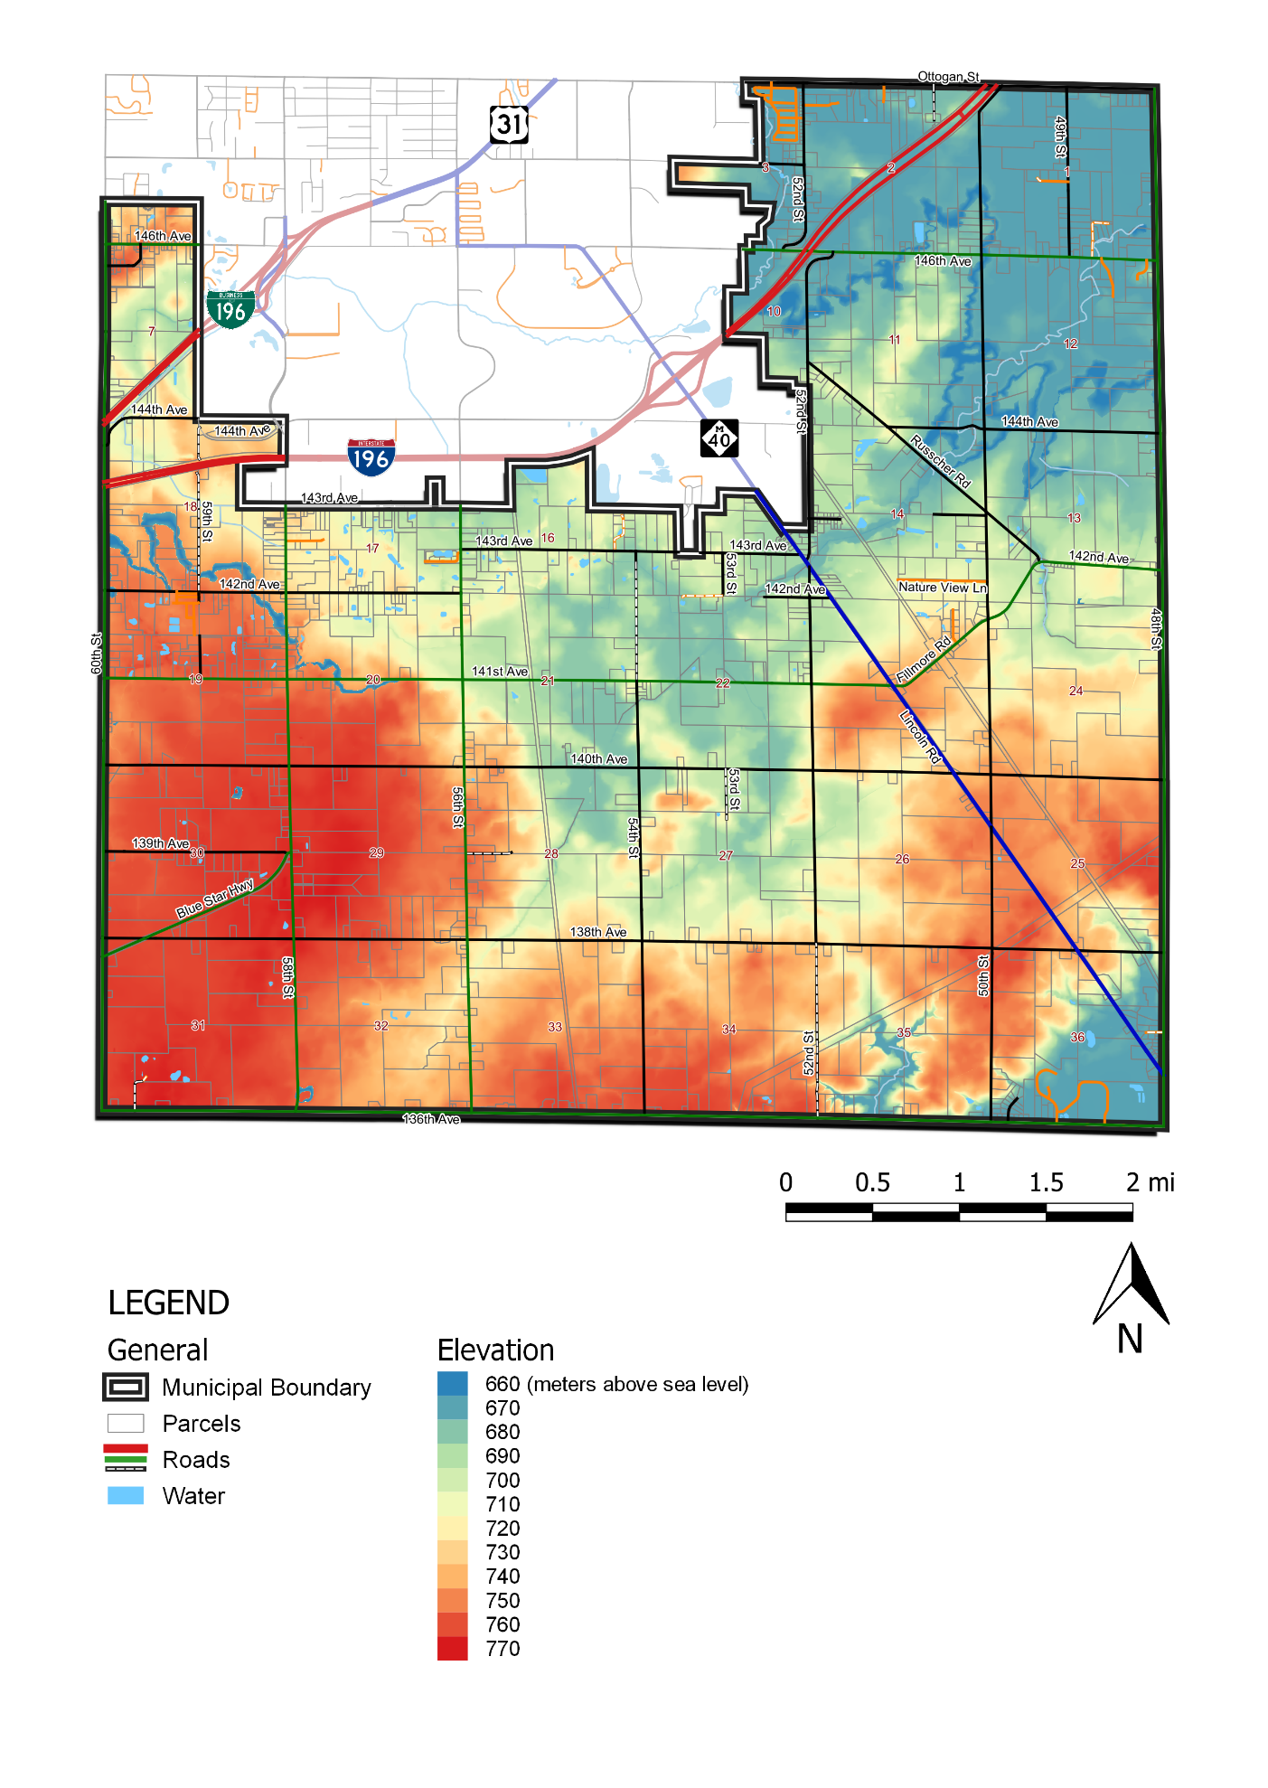
Map 3.2. Hydrology
Fillmore Township is home to 141 recognized bodies of still surface water comprising approximately 86 acres, though none are prominent enough to warrant names. The median body comprises just over a third of an acre (0.375 acres) and may be most commonly found across Sections 16, 17, and 19 just south of I-196.
The Township also hosts a number of free flowing creeks, streams, and drains, including the south branch of the Macatawa River in the northwest corner, the Tulip Intercounty Drain along the east boundary of the City of Holland, and the VanderBie & Rotman Drain and Fillmore Drain Number 8 in Section 18, just south of I-196.
Despite the lack of major bodies of surface water, the Township hosts approximately 788 acres of identified wetlands and 1,266 acres of one (1%) percent annual floodplains. The former can largely be found concentrated around the small ponds south of the City, alluding to the area’s generally swampy nature. Conversely, floodplains appear to follow flowing bodies of water like the aforementioned drains and Macatawa River tributary, though a wide area can be identified in Sections 21, 22, 26, and 27. These floodplains occupy the centrally located lands, likely collecting runoff from the higher elevations to the southeast and feeding them into the Macatawa River tributary to the northeast.
Hydrological features are illustrated in Map 3.2 on the following page.
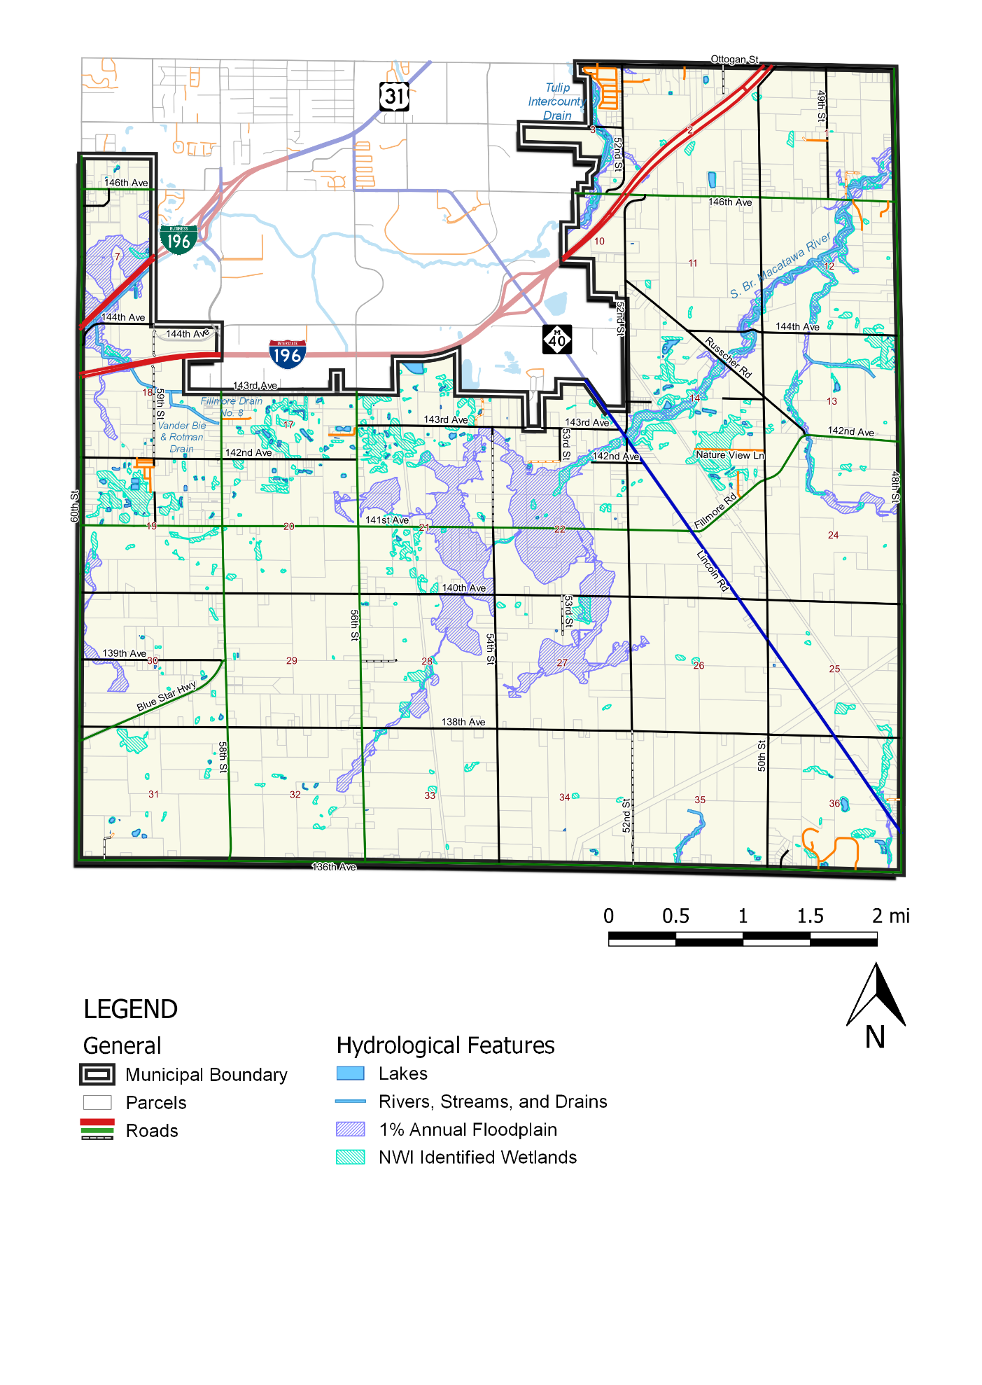

Map 3.3. Soils
The majority of the Township rests upon loamy soils, primarily found in the south central and southeast. Within this loam, a patch of muck (Sections 21 and 28) loosely corresponds with the swath of floodplains identified in the previous Map 3.2, perhaps contributing to its penchant for flooding.
To the north of loam, particularly centered in Sections 13 and 14 east of the City, is a conglomerate of sandy soils. Much of the rest of the Township is composed of complex soils, identified primarily as being a significant mix of two or more separate soil types which defies conventional categorization. These soils occupy both the Township’s highest elevations in the southwest and lowest in the northeast and southeast (see Map 3.1).
Distribution of soil associations are illustrated in Map 3.3 on the following page.
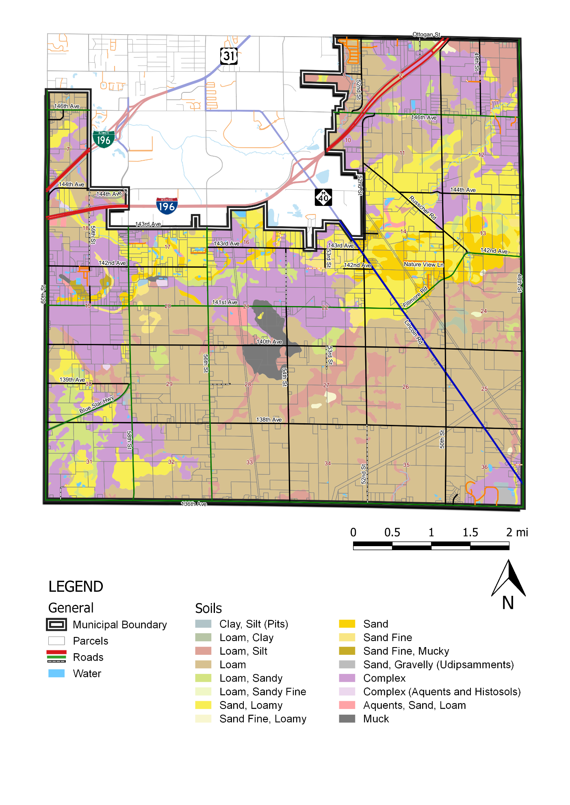
Map 3.4. Prime Farmland
Prime farmland is defined by the United States Department of Agriculture’s (USDA) National Resource Conservation Service (NRCS) as follows:
“Prime farmland is land that has the best combination of physical and chemical characteristics for producing food, feed, forage, fiber, and oilseed crops and that is available for these uses. It has the combination of soil properties, growing season, and moisture supply needed to produce sustained high yields of crops in an economic manner if it is treated and managed according to acceptable farming methods.
In general, prime farmland has an adequate and dependable water supply from precipitation or irrigation, a favorable temperature and growing season, an acceptable level of acidity or alkalinity, an acceptable content of salt or sodium, and few or no rocks. Its soils are permeable to water and air. Prime farmland is not excessively eroded or saturated with water for long periods of time, and it either does not flood frequently during the growing season or is protected from flooding. Users of the lists of prime farmland map units should recognize that soil properties are only one of several criteria that are necessary. Other considerations include land use, frequency of flooding, irrigation, water table, and wind erodibility.”
— USDA NRCS Field Office Technical Guide, 2015
Farmland of local importance is likewise defined as follows:
“Farmland of Local Importance is land that is locally important for crop production, but not categorized as prime farmland, unique farmland, or farmland of statewide importance. This farmland is identified by the appropriate local agencies. Farmland of Local Importance may include tracts of land that have been designated for agriculture by local ordinance.”
— USDA NRCS Field Office Technical Guide, 2015
The majority of prime farmland and adjacent classifications are located in the south central and southeast regions of the Township. As indicated in Map 3.3, the distribution of viable farmland coincides with the placement of less porous soils such as loam and muck. However, other geographical features such as man-made irrigation and natural elevations may likewise affect the results.
Prime farmland and farmland of local importance are illustrated in Map 3.4 on the following page.
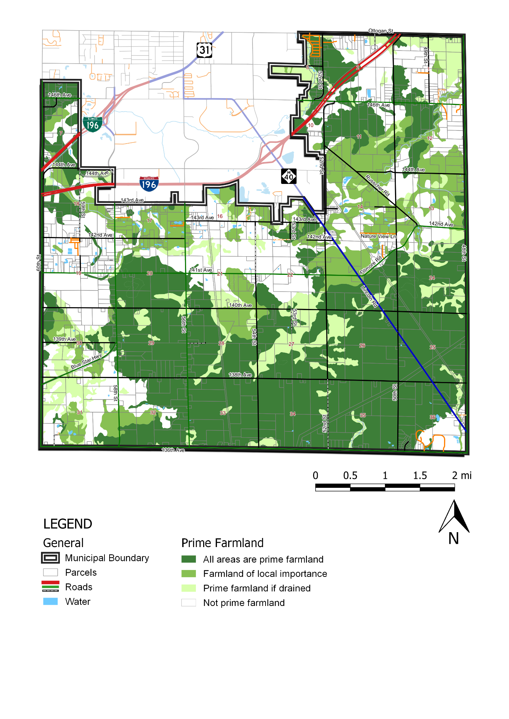
Map 3.5. Transportation
Fillmore Township benefits from being located between the City of Holland to the north, the Cities of Saugatuck and Douglas to the southwest, and the unincorporated community of Hamilton to the southeast, providing residents ample choices for employment, necessities, and recreation. Said metropolitan areas are most directly accessed by State and federal thoroughfares like Interstate-196 to the north and west and M-40 cutting diagonally from the southeast corner up into Holland.
Additional major corridors include the County Primary roads Blue Star Highway and Fillmore Road/142nd Avenue. The former, beginning at the intersection of 139th Avenue and 58th Street, takes drivers southwest directly into downtown Saugatuck while the latter, connecting 141st Avenue and the County Local Russcher Road, takes drivers west into the unincorporated community of Overisel.
Additional modes of transit include the dual CSX Transportation Railroads which extend southward out of Holland and exit the Township through Sections 33 and 36. The west line proceeds southward through the City of Fennville and eventually off toward Chicago while the east line terminates in Hamilton. Both lines exclusively ship freight.
Finally, the Township maintains several roads providing connection to the nearby West Michigan Regional Airport located just inside the Holland city limits, including 144th Avenue and 58th Street. The public airport, owned by the City of Holland and operated by the West Michigan Airport Authority, comprises 432 acres with a single runway and hosts an approximate 32,000 aircraft per year.¹
Transportation corridors and facilities are illustrated in Map 3.5 on the following page.
Insert below footnote:
- https://westmichiganregionalairport.com/about/airport-data/
